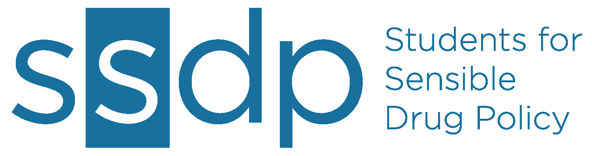
1317 F Street NW
Suite 501
Washington, DC 20004
(202)393-5280
ssdp.org

FOR IMMEDIATE RELEASE

Contact: Stacia Cosner, SSDP National, stacia@ssdp.org, 410-299-3433
Jane ChapterLeader, [[SCHOOL]] SSDP, [[YOUR PHONE NUMBER]], [[YOUR EMAIL]]

Students “die-in” on International Overdose Awareness Day
[[YOUR SCHOOL]] group draws attention to preventable drug overdose deaths
WASHINGTON, DC - Each year, the lives of more than 28,000 Americans are claimed by a drug overdose. In the past few years, accidental drug overdoses became second only to car accidents as the leading cause of preventable death in the U.S. This dangerous trend has prompted advocates to organize a day dedicated to the issue -- International Overdose Awareness Day is this Friday, August 31.
Members from the [[SCHOOL]] chapter of Students for Sensible Drug Policy will lay down, wearing all black, at [[TIME]] tomorrow to draw attention to the issue of drug overdose deaths.
According to ssdp.org, when someone in America overdoses, a call for help is made less than 50% of the time. It is the aim of SSDP to increase calls for help when a drug or alcohol overdose is involved. Stacia Cosner, Associate Director for SSDP, added “It is our hope that campuses and states will enact life-saving ‘Call 911 Good Samaritan Policies’ to remove the threat of punishment that currently presents a barrier to seeking help in overdose situations.”
Students who are aware that a “Call 911 Good Samaritan” policy is in effect are 2.5 times more likely than students who expect to face disciplinary actions to call for help when witnessing the signs of alcohol poisoning. More than 100 colleges and universities currently have some form of this policy in place.
“I think it’s tragic that students cite fear of police involvement as the most common reason for not calling 911 during an overdose,” said Jane ChapterLeader, President of [[SCHOOL]] SSDP. “Nothing should cause young people to hesitate to call for help in such life-threatening situations.”

###
Students for Sensible Drug Policy is the only international network of students dedicated to ending the war on drugs. At heart, SSDP is a grassroots organization, led by a student-run board of directors. We create change by bringing young people together and creating safe spaces for students of all political and ideological stripes to have honest conversations about drugs and drug policy. Founded in 1998, SSDP comprises thousands of members at hundreds of campuses in countries around the globe.

